**Module 4 (Java Scripts Basics and DOM)**

1. What is JavaScript?

* JavaScript is a scripting language.
* JavaScript  is a scripting language that enables you to create dynamically updating content, control multimedia, animate images, and pretty much everything else.
* JavaScript has 2 priority. I) internal II) external.
* JS uswed ES-6 (Ekma Script) version 6 because it can used same JS in every browser.
* JS have more than 14lakh plus libraries And frameworks.
* JavaScript is a text-based programming language used both on the client-side and server-side that allows you to make web pages interactive. Where HTML and CSS are languages that give structure and style to web pages, JavaScript gives web pages interactive elements that engage a user.

1. What is the use of is NaN function?

* The JavaScript is NaN() Function is used to check whether a given value is an illegal number or not.

1. What is negative Infinity?

* NEGATIVE_INFINITY is a special numeric value that is returned when an arithmetic operation or mathematical function generates a negative value greater than the largest representable number in JavaScript (i.e., more negative than -Number. MAX_VALUE) . JavaScript displays the NEGATIVE_INFINITY value as -Infinity .

1. Which company developed JavaScript?

* JavaScript was invented by Brendan Eich in 1995. It was developed for Netscape 2, and became the ECMA-262 standard in 1997.
* After Netscape handed JavaScript over to ECMA, the Mozilla foundation continued to develop JavaScript for the Firefox browser.

1. What are undeclared and undefined variables?

* Undefined variable means a variable has been declared but does not have a value.
* Undeclared variable means that the variable does not exist in the program at all.

1. Write the code for adding new elements dynamically?

document.createElement("<*tagName*>");

// Where <*tagName*> can be any HTML

// tagName like div, ul, button, etc.

// newDiv element has been created

For Eg: let newDiv = document.createElement("div");

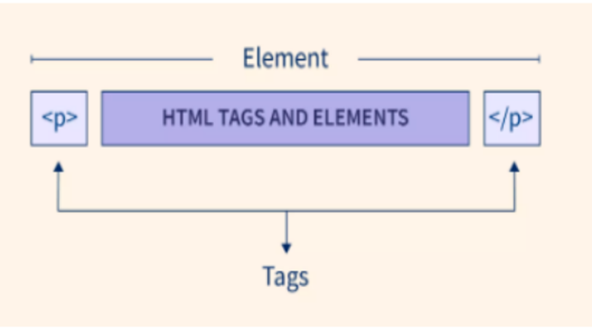

1. What is the difference between ViewState and SessionState?

* A ViewState is a state of a page within a browser wherein the values of controls persist when post back operation is done. When another page is loaded, the previous page data is no longer available.
* SessionState is the data of a user session and is maintained on the server side.

1. What is === operator?

* The **strict equality (**===**)** operator checks whether its two operands are equal, returning a Boolean result. Unlike the [equality](https://developer.mozilla.org/en-US/docs/Web/JavaScript/Reference/Operators/Equality) operator, the strict equality operator always considers operands of different types to be different.

1. How can the style/class of an element be changed?

* Another way to alter the style of an element is by changing its class attribute. class is a reserved word in JavaScript, so in order to access the element's class, you use element. className .

1. How to read and write a file using JavaScript?

* readFile() and rs. writeFile() methods are used to read and write of a file using javascript. The file is read using the fs. readFile() function, which is an inbuilt method.

1. What are all the looping structures in JavaScript?

* JavaScript supports different kinds of loops:
* for - loops through a block of code a number of times
* for/in - loops through the properties of an object
* for/of - loops through the values of an iterable object
* while - loops through a block of code while a specified condition is true
* do/while - also loops through a block of code while a specified condition is true.

1. How can you convert the string of any base to an integer in JavaScript?

* To convert a string to an integer parseInt(), Number(), and Unary operator(+) function is used in javascript. parseInt() function returns Nan( not a number) when the string doesn't contain number.
* If a string with a number is sent, then only that number will be returned as the output.

1. What is the function of the delete operator?

* The delete operator removes a property from an object. If the property's value is an object and there are no more references to the object, the object held by that property is eventually released automatically.

1. What are all the types of Pop up boxes available in JavaScript?

* JavaScript has three kind of popup boxes: Alert box, Confirm box, and Prompt box.

1. What is the use of Void (0)?

* void(0)” is similar to void. javascript: void(0) means return undefined as a primitive value.
* We use this to prevent any negative effects on a webpage when we insert some expression. For example, in the case of URL hyperlinks.

1. How can a page be forced to load another page in JavaScript?

* In JavaScript, we can use window. location object to force a page to load another page.

1. What are the disadvantages of using innerHTML in JavaScript?

* Event handlers attached to any DOM element are preserved.
* Replacement is done everywhere.
* It is not possible to append innerHTML.
* Breaks the document.
* Used for Cross-site Scripting.